UNITED STATES
SECURITIES AND EXCHANGE COMMISSION
Washington, D.C. 20549

FORM 8-K

CURRENT REPORT

Pursuant to Section 13 or 15(d)
of the Securities Exchange Act of 1934

Date of Report (Date of earliest event reported): September 9, 2026

XERIS BIOPHARMA HOLDINGS, INC.

(Exact name of registrant as specified in its charter)
Delaware |  |  |  |  |  | 001-40880 |  |  |  |  |  | 87-1082097
(State or other jurisdiction of  incorporation) |  |  |  |  |  | (Commission  File Number) |  |  |  |  |  | (I.R.S. Employer  Identification No.)

1375 West Fulton Street, Suite 1300
Chicago, Illinois 60607
(Address of principal executive offices, including zip code)

(844) 445-5704
(Registrant's telephone number, including area code)

Not Applicable
(Former name or former address, if changed since last report)
Check the appropriate box below if the Form 8-K filing is intended to simultaneously satisfy the filing obligation of the registrant under any of the following provisions:
☐ |  |  | Written communications pursuant to Rule 425 under the Securities Act (17 CFR 230.425)
☐ |  |  | Soliciting material pursuant to Rule 14a-12 under the Exchange Act (17 CFR 240.14a-12)
☐ |  |  | Pre-commencement communications pursuant to Rule 14d-2(b) under the Exchange Act (17 CFR 240.14d-2(b))
☐ |  |  | Pre-commencement communications pursuant to Rule 13e-4(c) under the Exchange Act (17 CFR 240.13e-4(c))
Securities registered pursuant to Section 12(b) of the Act:
Title of each class |  |  |  |  |  |  |  |  |  |  |  | Trading Symbol(s) |  |  |  |  |  | Name of each exchange on which registered
Common Stock, par value $0.0001 per share |  |  |  |  |  |  |  |  |  |  |  | XERS |  |  |  |  |  | The Nasdaq Global Select Market
Indicate by check mark whether the registrant is an emerging growth company as defined in Rule 405 of the Securities Act of 1933 (§ 230.405 of this chapter) or Rule 12b-2 of the Securities Exchange Act of 1934 (§ 240.12b-2 of this chapter).

Emerging growth company ☐

If an emerging growth company, indicate by check mark if the registrant has elected not to use the extended transition period for complying with any new or revised financial accounting standards provided pursuant to Section 13(a) of the Exchange Act. ☐

Item 7.01 Regulation FD Disclosure.
Xeris Biopharma Holdings, Inc. (the “Company”) will host an XP-8121 Program Overview (Webinar) on September 9, 2026. A copy of the slide presentation to be used by the Company's senior management in discussions with investors (the “Presentation”) is furnished as Exhibit 99.1 to this Current Report on Form 8-K and is incorporated into this Item 7.01 by reference. A copy of the Presentation will also be accessible on the Company's website at www.xerispharma.com under the “Investors” tab.
On September 9, 2026, the Company issued a press release announcing the XP-8121 Program Overview, a copy of which is furnished as Exhibit 99.2 to this Current Report on Form 8-K and is incorporated into this Item 7.01 by reference.
The information in this Item 7.01, including Exhibit 99.1 and Exhibit 99.2, is being furnished and shall not be deemed to be “filed” for purposes of Section 18 of the Securities Exchange Act of 1934, as amended (the “Exchange Act”), or otherwise subject to the liabilities of that section and shall not be deemed incorporated by reference into any registration statement or other document filed pursuant to the Securities Act of 1933, as amended, or the Exchange Act, except as expressly set forth by specific reference in such filing. In addition, the reference to the Company's website is provided as an inactive textual reference only, and the contents of the Company's website are not incorporated by reference into, and should not be considered part of, this Current Report on Form 8-K.

Item 9.01 Financial Statements and Exhibits.
(d) Exhibits
Exhibit Number |  |  |  |  |  | Description
99.1 |  |  |  |  |  | Investor Presentation
99.2 |  |  |  |  |  | Press release, dated September 9, 2026, issued by the Company
104 |  |  |  |  |  | Cover Page Interactive Data File (embedded within the Inline XBRL document)

SIGNATURES

Pursuant to the requirements of the Securities Exchange Act of 1934, the registrant has duly caused this report to be signed on its behalf by the undersigned hereunto duly authorized.

Date: September 9, 2026 |  |  |  |  |  |  |  |  | Xeris Biopharma Holdings, Inc.
 |  |  |  |  |  |  |  |  | By: |  |  | /s/ Steven M. Pieper
 |  |  |  |  |  |  |  |  |  |  |  | Name: Steven M. Pieper
 |  |  |  |  |  |  |  |  |  |  |  | Title: Chief Financial Officer

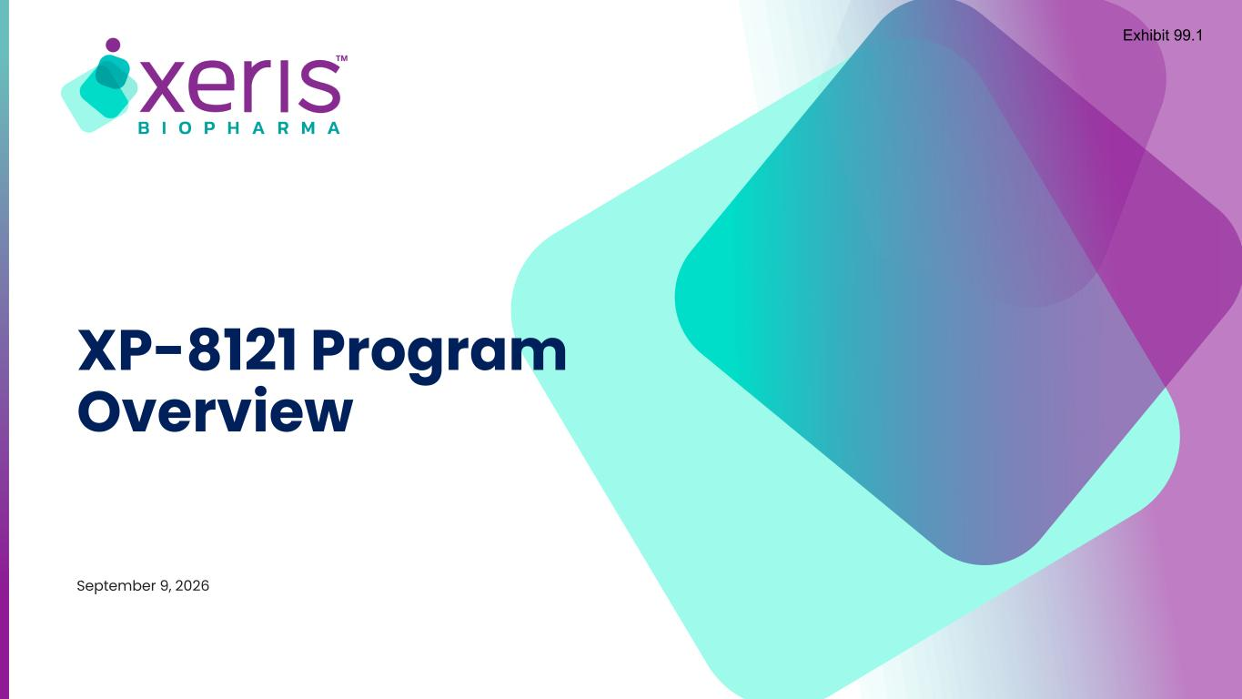

XP-8121 Program Overview September 9, 2026 Exhibit 99.1

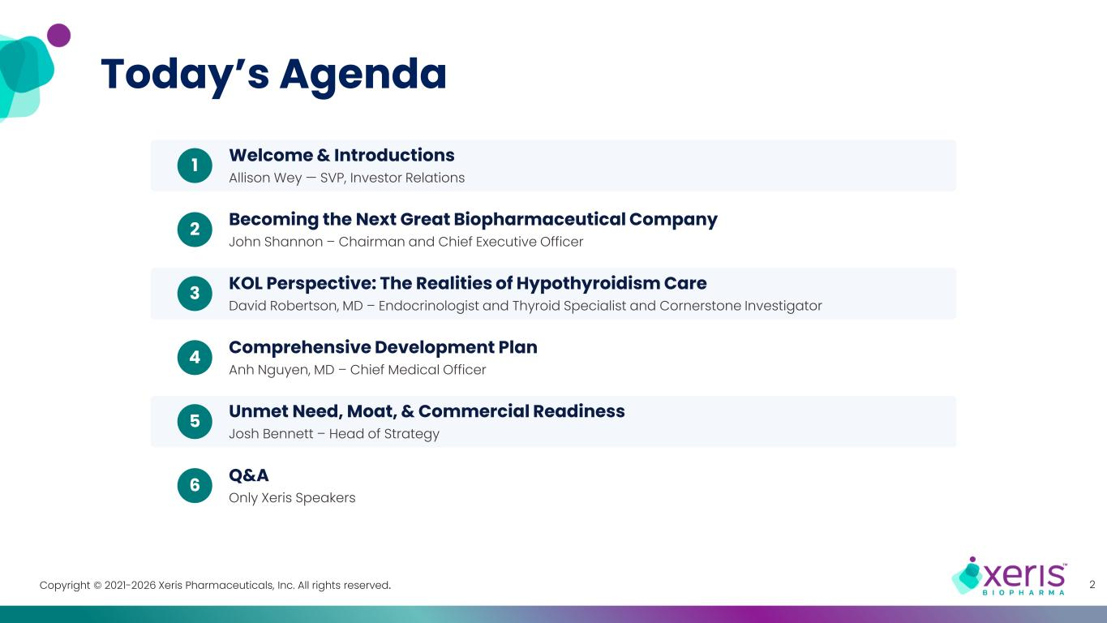
Copyright © 2021-2026 Xeris Pharmaceuticals, Inc. All rights reserved. Today’s Agenda 2 1 Welcome & Introductions Allison Wey — SVP, Investor Relations 2 Becoming the Next Great Biopharmaceutical Company John Shannon – Chairman and Chief Executive Officer 3 KOL Perspective: The Realities of Hypothyroidism Care David Robertson, MD – Endocrinologist and Thyroid Specialist and Cornerstone Investigator 4 Comprehensive Development Plan Anh Nguyen, MD – Chief Medical Officer 5 Unmet Need, Moat, & Commercial Readiness Josh Bennett – Head of Strategy 6 Q&A Only Xeris Speakers

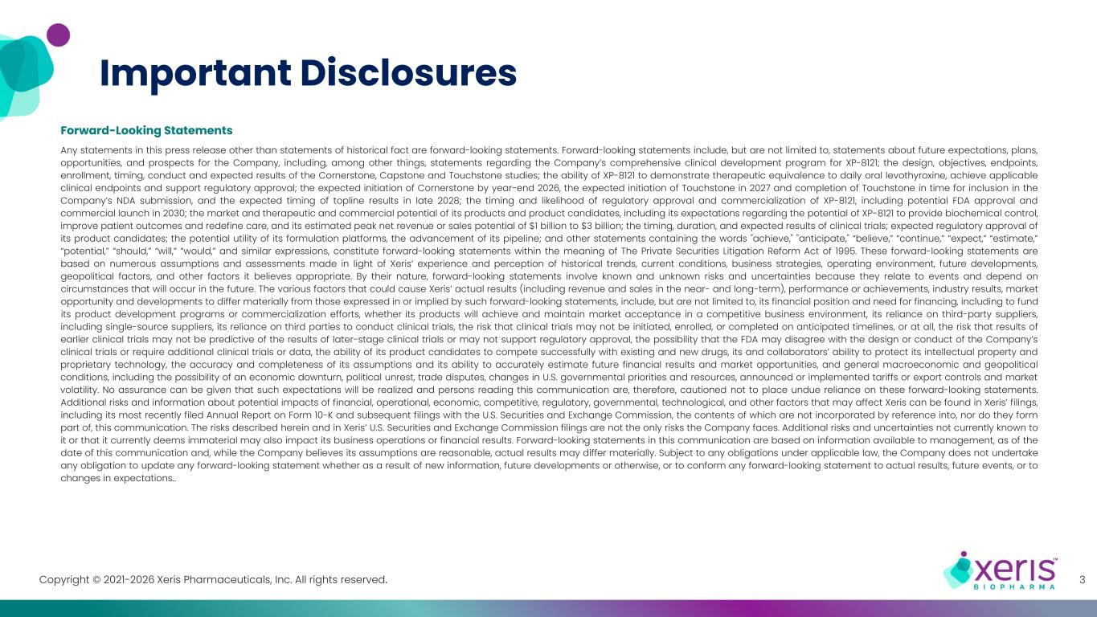
Copyright © 2021-2026 Xeris Pharmaceuticals, Inc. All rights reserved. Important Disclosures Forward-Looking Statements Any statements in this press release other than statements of historical fact are forward-looking statements. Forward-looking statements include, but are not limited to, statements about future expectations, plans, opportunities, and prospects for the Company, including, among other things, statements regarding the Company’s comprehensive clinical development program for XP-8121; the design, objectives, endpoints, enrollment, timing, conduct and expected results of the Cornerstone, Capstone and Touchstone studies; the ability of XP-8121 to demonstrate therapeutic equivalence to daily oral levothyroxine, achieve applicable clinical endpoints and support regulatory approval; the expected initiation of Cornerstone by year-end 2026, the expected initiation of Touchstone in 2027 and completion of Touchstone in time for inclusion in the Company’s NDA submission, and the expected timing of topline results in late 2028; the timing and likelihood of regulatory approval and commercialization of XP-8121, including potential FDA approval and commercial launch in 2030; the market and therapeutic and commercial potential of its products and product candidates, including its expectations regarding the potential of XP-8121 to provide biochemical control, improve patient outcomes and redefine care, and its estimated peak net revenue or sales potential of $1 billion to $3 billion; the timing, duration, and expected results of clinical trials; expected regulatory approval of its product candidates; the potential utility of its formulation platforms, the advancement of its pipeline; and other statements containing the words "achieve," "anticipate," “believe,” “continue,” “expect,” “estimate,” “potential,” “should,” “will,” “would,” and similar expressions, constitute forward-looking statements within the meaning of The Private Securities Litigation Reform Act of 1995. These forward-looking statements are based on numerous assumptions and assessments made in light of Xeris’ experience and perception of historical trends, current conditions, business strategies, operating environment, future developments, geopolitical factors, and other factors it believes appropriate. By their nature, forward-looking statements involve known and unknown risks and uncertainties because they relate to events and depend on circumstances that will occur in the future. The various factors that could cause Xeris’ actual results (including revenue and sales in the near- and long-term), performance or achievements, industry results, market opportunity and developments to differ materially from those expressed in or implied by such forward-looking statements, include, but are not limited to, its financial position and need for financing, including to fund its product development programs or commercialization efforts, whether its products will achieve and maintain market acceptance in a competitive business environment, its reliance on third-party suppliers, including single-source suppliers, its reliance on third parties to conduct clinical trials, the risk that clinical trials may not be initiated, enrolled, or completed on anticipated timelines, or at all, the risk that results of earlier clinical trials may not be predictive of the results of later-stage clinical trials or may not support regulatory approval, the possibility that the FDA may disagree with the design or conduct of the Company’s clinical trials or require additional clinical trials or data, the ability of its product candidates to compete successfully with existing and new drugs, its and collaborators’ ability to protect its intellectual property and proprietary technology, the accuracy and completeness of its assumptions and its ability to accurately estimate future financial results and market opportunities, and general macroeconomic and geopolitical conditions, including the possibility of an economic downturn, political unrest, trade disputes, changes in U.S. governmental priorities and resources, announced or implemented tariffs or export controls and market volatility. No assurance can be given that such expectations will be realized and persons reading this communication are, therefore, cautioned not to place undue reliance on these forward-looking statements. Additional risks and information about potential impacts of financial, operational, economic, competitive, regulatory, governmental, technological, and other factors that may affect Xeris can be found in Xeris’ filings, including its most recently filed Annual Report on Form 10-K and subsequent filings with the U.S. Securities and Exchange Commission, the contents of which are not incorporated by reference into, nor do they form part of, this communication. The risks described herein and in Xeris’ U.S. Securities and Exchange Commission filings are not the only risks the Company faces. Additional risks and uncertainties not currently known to it or that it currently deems immaterial may also impact its business operations or financial results. Forward-looking statements in this communication are based on information available to management, as of the date of this communication and, while the Company believes its assumptions are reasonable, actual results may differ materially. Subject to any obligations under applicable law, the Company does not undertake any obligation to update any forward-looking statement whether as a result of new information, future developments or otherwise, or to conform any forward-looking statement to actual results, future events, or to changes in expectations.. 3

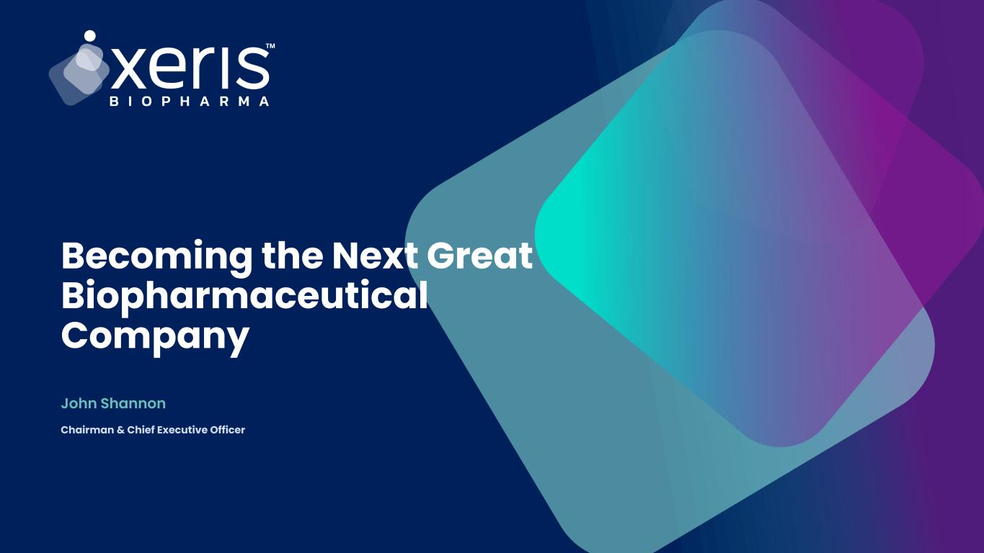
John Shannon Becoming the Next Great Biopharmaceutical Company Chairman & Chief Executive Officer

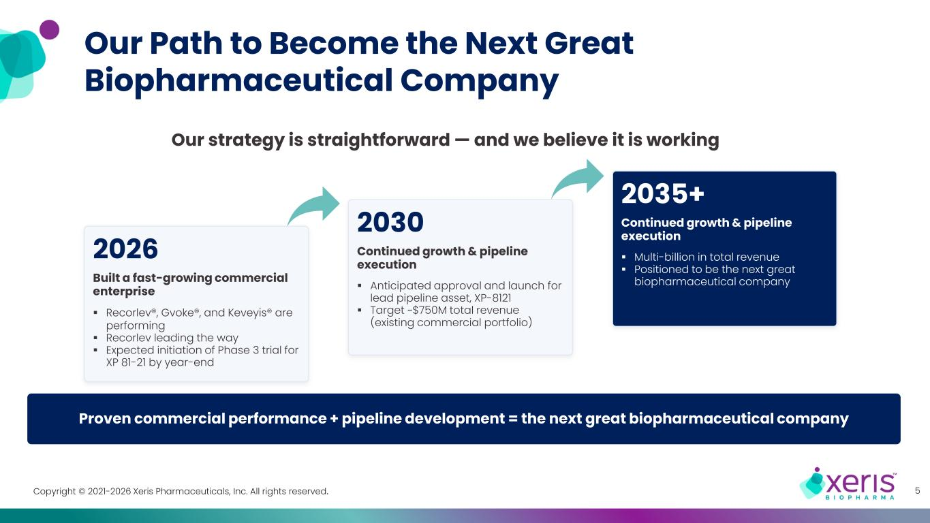
Copyright © 2021-2026 Xeris Pharmaceuticals, Inc. All rights reserved. 5 2026 ▪ Recorlev®, Gvoke®, and Keveyis® are performing ▪ Recorlev leading the way ▪ Expected initiation of Phase 3 trial for XP 81-21 by year-end Built a fast-growing commercial enterprise Our Path to Become the Next Great Biopharmaceutical Company 2030 ▪ Anticipated approval and launch for lead pipeline asset, XP-8121 ▪ Target ~$750M total revenue (existing commercial portfolio) Continued growth & pipeline execution 2035+ ▪ Multi-billion in total revenue ▪ Positioned to be the next great biopharmaceutical company Continued growth & pipeline execution Proven commercial performance + pipeline development = the next great biopharmaceutical company Our strategy is straightforward — and we believe it is working

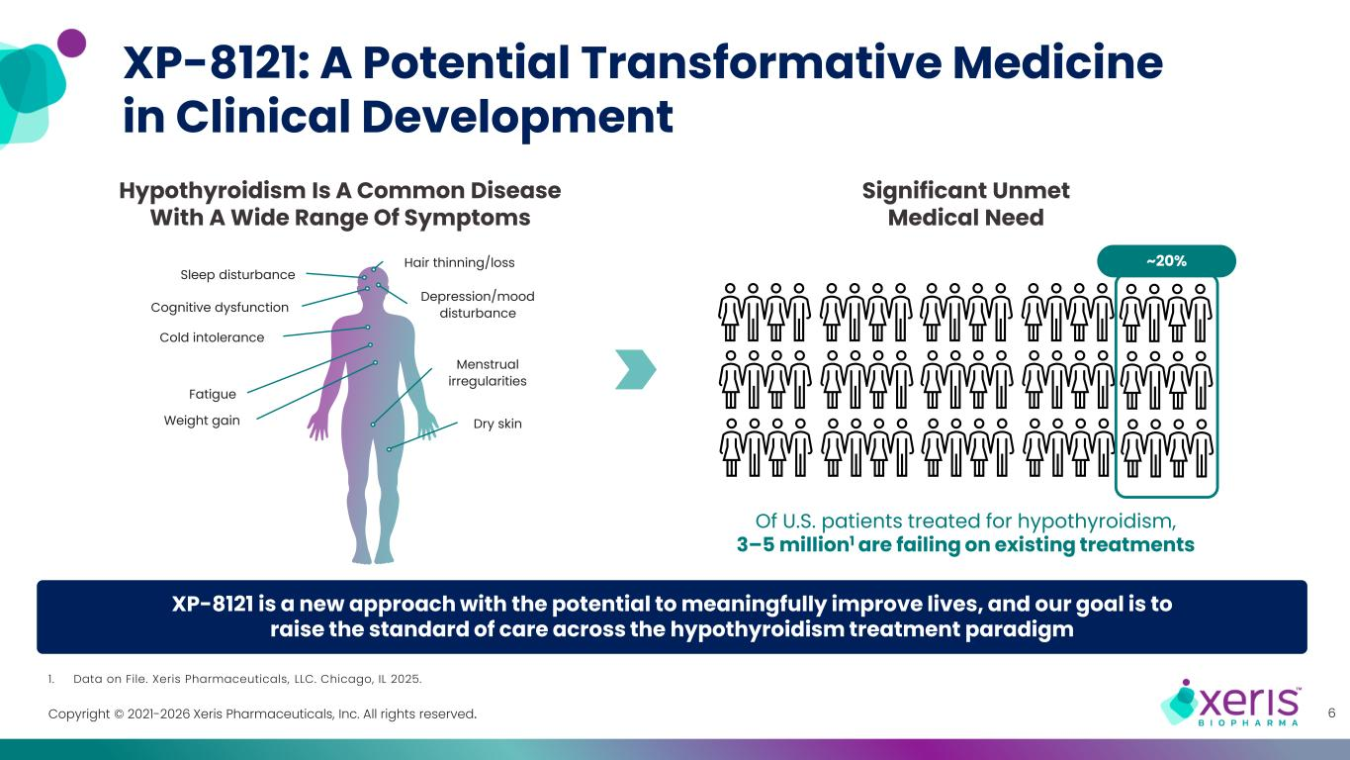
Copyright © 2021-2026 Xeris Pharmaceuticals, Inc. All rights reserved. XP-8121 is a new approach with the potential to meaningfully improve lives, and our goal is to raise the standard of care across the hypothyroidism treatment paradigm XP-8121: A Potential Transformative Medicine in Clinical Development 6 Significant Unmet Medical Need Of U.S. patients treated for hypothyroidism, 3–5 million1 are failing on existing treatments ~20% Sleep disturbance Menstrual irregularities Dry skin Hair thinning/loss Cold intolerance Depression/mood disturbance Weight gain Cognitive dysfunction Fatigue Hypothyroidism Is A Common Disease With A Wide Range Of Symptoms 1. Data on File. Xeris Pharmaceuticals, LLC. Chicago, IL 2025.

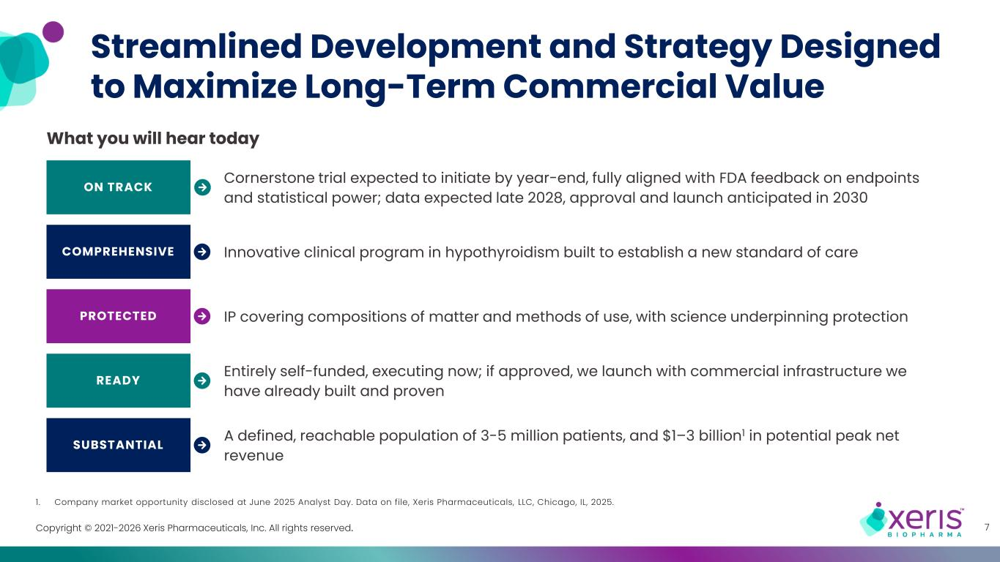
Copyright © 2021-2026 Xeris Pharmaceuticals, Inc. All rights reserved. Streamlined Development and Strategy Designed to Maximize Long-Term Commercial Value 7 What you will hear today ON TRACK Cornerstone trial expected to initiate by year-end, fully aligned with FDA feedback on endpoints and statistical power; data expected late 2028, approval and launch anticipated in 2030 COMPREHENSIVE Innovative clinical program in hypothyroidism built to establish a new standard of care PROTECTED IP covering compositions of matter and methods of use, with science underpinning protection READY Entirely self-funded, executing now; if approved, we launch with commercial infrastructure we have already built and proven SUBSTANTIAL A defined, reachable population of 3-5 million patients, and $1–3 billion1 in potential peak net revenue 1. Company market opportunity disclosed at June 2025 Analyst Day. Data on file, Xeris Pharmaceuticals, LLC, Chicago, IL, 2025.

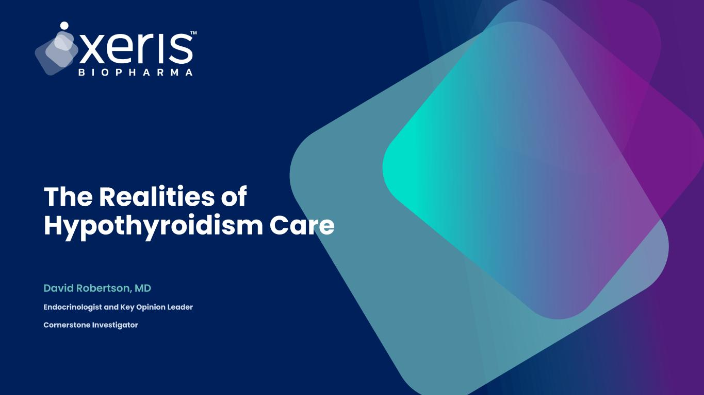
David Robertson, MD The Realities of Hypothyroidism Care Endocrinologist and Key Opinion Leader Cornerstone Investigator

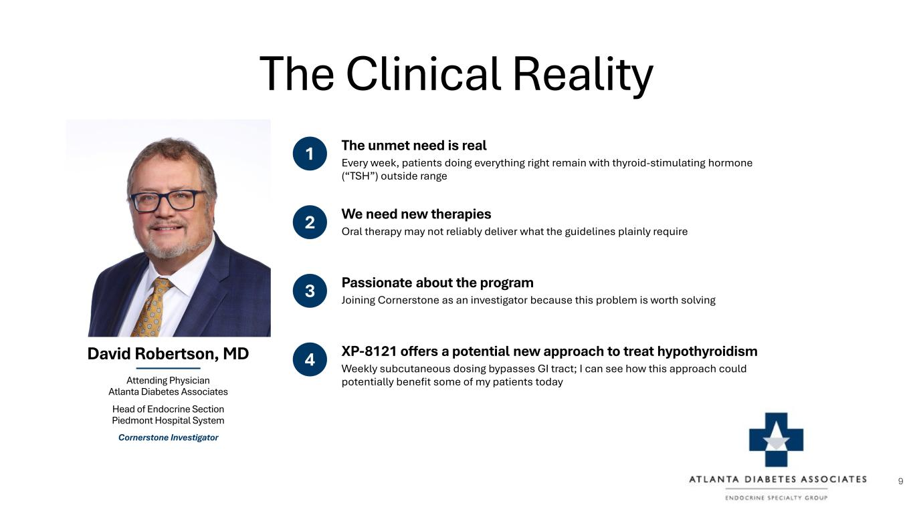
The Clinical Reality David Robertson, MD Attending Physician Atlanta Diabetes Associates Head of Endocrine Section Piedmont Hospital System Cornerstone Investigator 2 We need new therapies Oral therapy may not reliably deliver what the guidelines plainly require 1 The unmet need is real Every week, patients doing everything right remain with thyroid-stimulating hormone (“TSH”) outside range 3 Passionate about the program Joining Cornerstone as an investigator because this problem is worth solving 4 XP-8121 offers a potential new approach to treat hypothyroidism Weekly subcutaneous dosing bypasses GI tract; I can see how this approach could potentially benefit some of my patients today 9

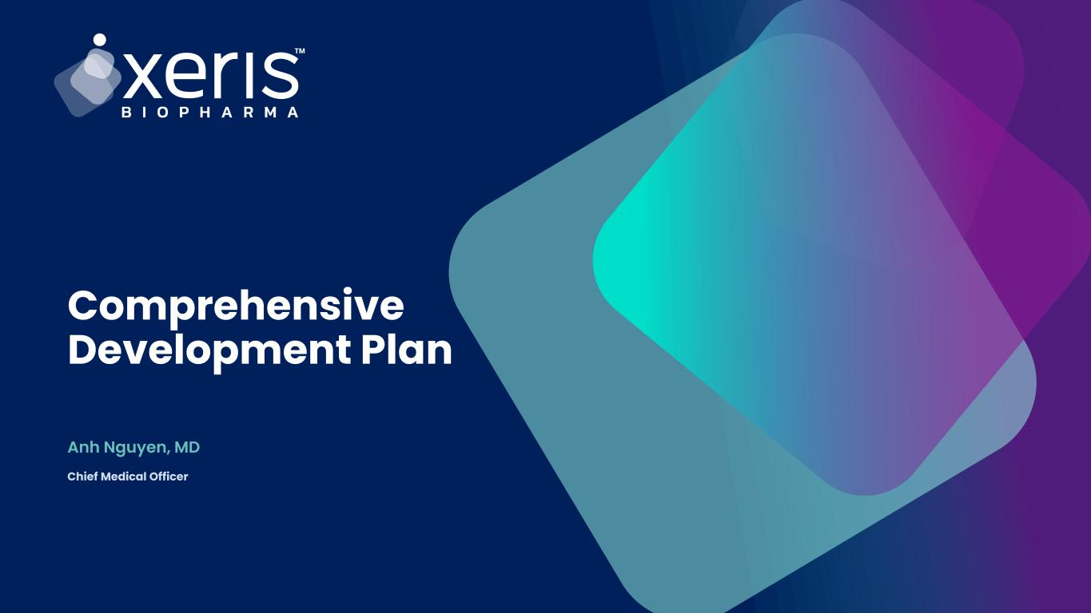
Anh Nguyen, MD Comprehensive Development Plan Chief Medical Officer

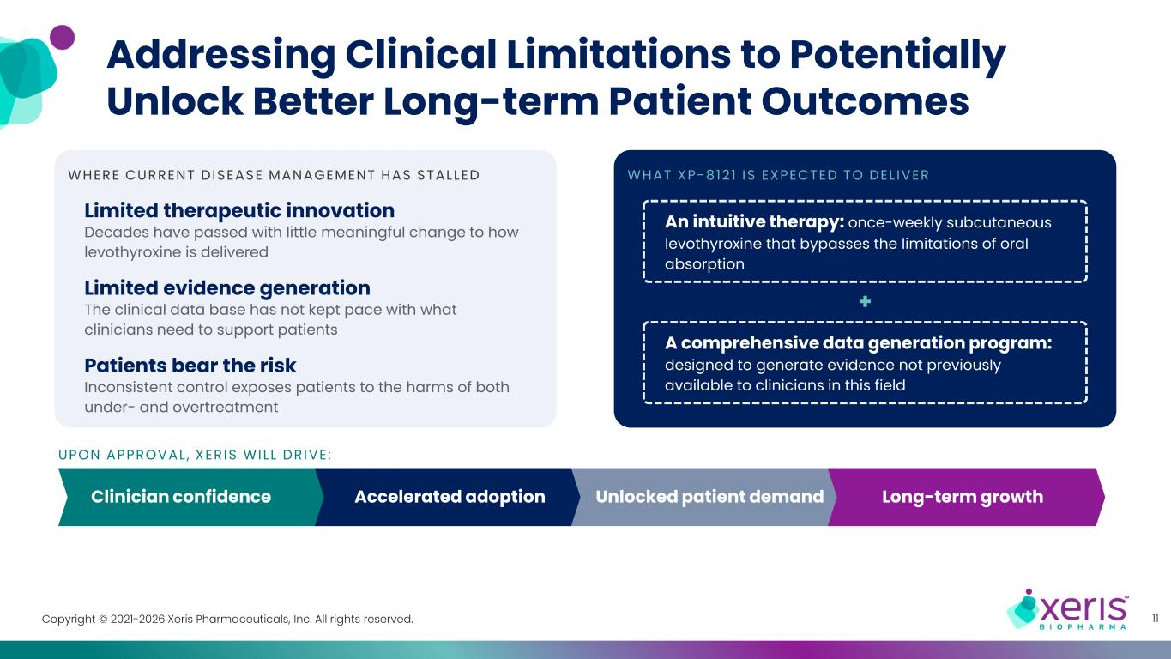
Copyright © 2021-2026 Xeris Pharmaceuticals, Inc. All rights reserved. Addressing Clinical Limitations to Potentially Unlock Better Long-term Patient Outcomes 11 WHERE CURRENT DISEASE MANAGEMENT HAS STALLED Limited therapeutic innovation Decades have passed with little meaningful change to how levothyroxine is delivered Limited evidence generation The clinical data base has not kept pace with what clinicians need to support patients Patients bear the risk Inconsistent control exposes patients to the harms of both under- and overtreatment WHAT XP-8121 IS EXPECTED TO DEL IVER An intuitive therapy: once-weekly subcutaneous levothyroxine that bypasses the limitations of oral absorption + A comprehensive data generation program: designed to generate evidence not previously available to clinicians in this field UPON APPROVAL , XERIS WILL DRIVE : Clinician confidence Accelerated adoption Unlocked patient demand Long-term growth

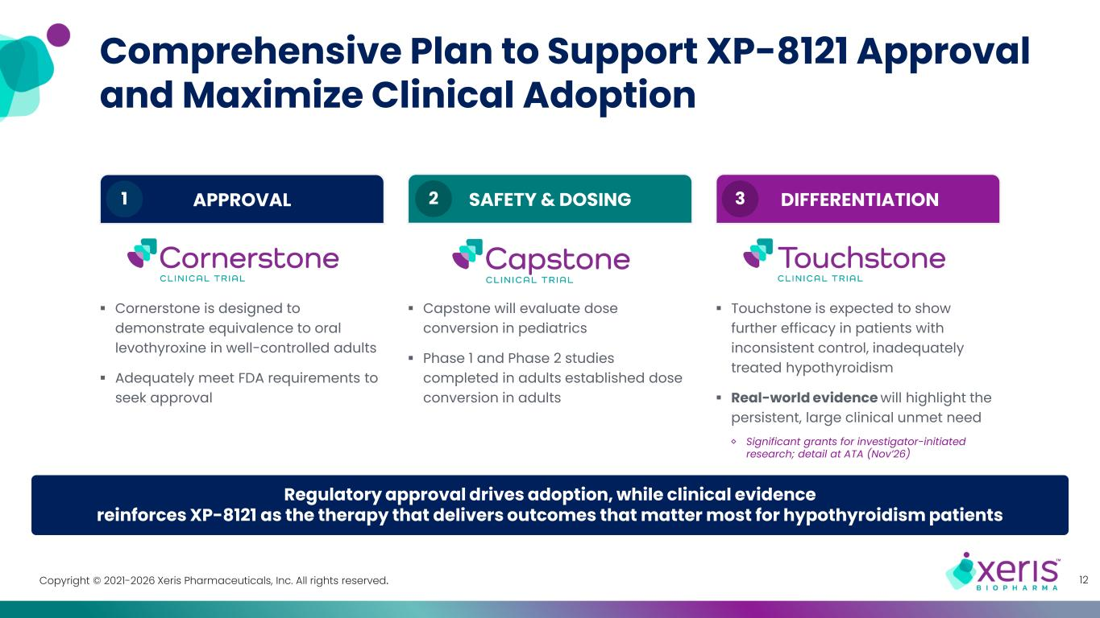
Copyright © 2021-2026 Xeris Pharmaceuticals, Inc. All rights reserved. Comprehensive Plan to Support XP-8121 Approval and Maximize Clinical Adoption 12 Regulatory approval drives adoption, while clinical evidence reinforces XP-8121 as the therapy that delivers outcomes that matter most for hypothyroidism patients ▪ Cornerstone is designed to demonstrate equivalence to oral levothyroxine in well-controlled adults ▪ Adequately meet FDA requirements to seek approval APPROVAL1 ▪ Capstone will evaluate dose conversion in pediatrics ▪ Phase 1 and Phase 2 studies completed in adults established dose conversion in adults 2 SAFETY & DOSING2 ▪ Touchstone is expected to show further efficacy in patients with inconsistent control, inadequately treated hypothyroidism ▪ Real-world evidence will highlight the persistent, large clinical unmet need ◊ Significant grants for investigator-initiated research; detail at ATA (Nov’26) DIFFERENTIATION3

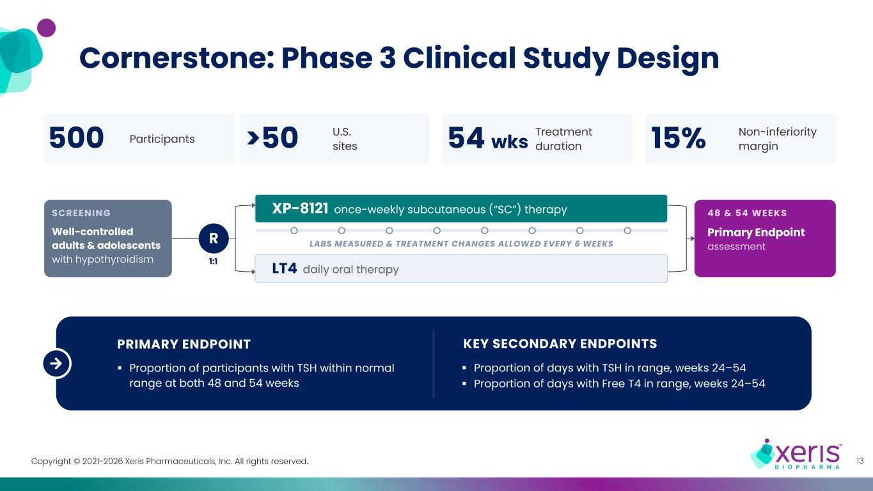
Copyright © 2021-2026 Xeris Pharmaceuticals, Inc. All rights reserved. Cornerstone: Phase 3 Clinical Study Design 13 500 Participants >50 U.S. sites 54 wks Treatment duration 15% Non-inferiority margin SCREENING Well-controlled adults & adolescents with hypothyroidism R 1:1 48 & 54 WEEKS Primary Endpoint assessment LT4 daily oral therapy XP-8121 once-weekly subcutaneous (“SC”) therapy LABS MEASURED & TREATMENT CHANGES ALLOWED EVERY 6 WEEKS PRIMARY ENDPOINT ▪ Proportion of participants with TSH within normal range at both 48 and 54 weeks KEY SECONDARY ENDPOINTS ▪ Proportion of days with TSH in range, weeks 24–54 ▪ Proportion of days with Free T4 in range, weeks 24–54

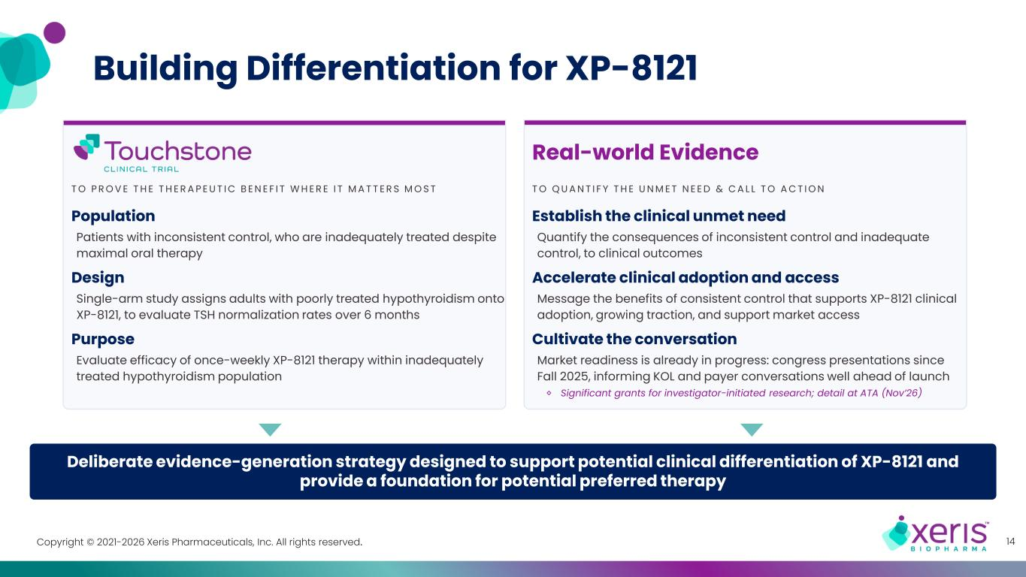
Copyright © 2021-2026 Xeris Pharmaceuticals, Inc. All rights reserved. Deliberate evidence-generation strategy designed to support potential clinical differentiation of XP-8121 and provide a foundation for potential preferred therapy 14 T O Q U A N T I F Y T H E U N M E T N E E D & C A L L T O A C T I O N Establish the clinical unmet need Quantify the consequences of inconsistent control and inadequate control, to clinical outcomes Accelerate clinical adoption and access Message the benefits of consistent control that supports XP-8121 clinical adoption, growing traction, and support market access Cultivate the conversation Market readiness is already in progress: congress presentations since Fall 2025, informing KOL and payer conversations well ahead of launch Building Differentiation for XP-8121 Real-world Evidence T O P R O V E T H E T H E R A P E U T I C B E N E F I T W H E R E I T M A T T E R S M O S T Population Patients with inconsistent control, who are inadequately treated despite maximal oral therapy Design Single-arm study assigns adults with poorly treated hypothyroidism onto XP-8121, to evaluate TSH normalization rates over 6 months Purpose Evaluate efficacy of once-weekly XP-8121 therapy within inadequately treated hypothyroidism population ◊ Significant grants for investigator-initiated research; detail at ATA (Nov’26)

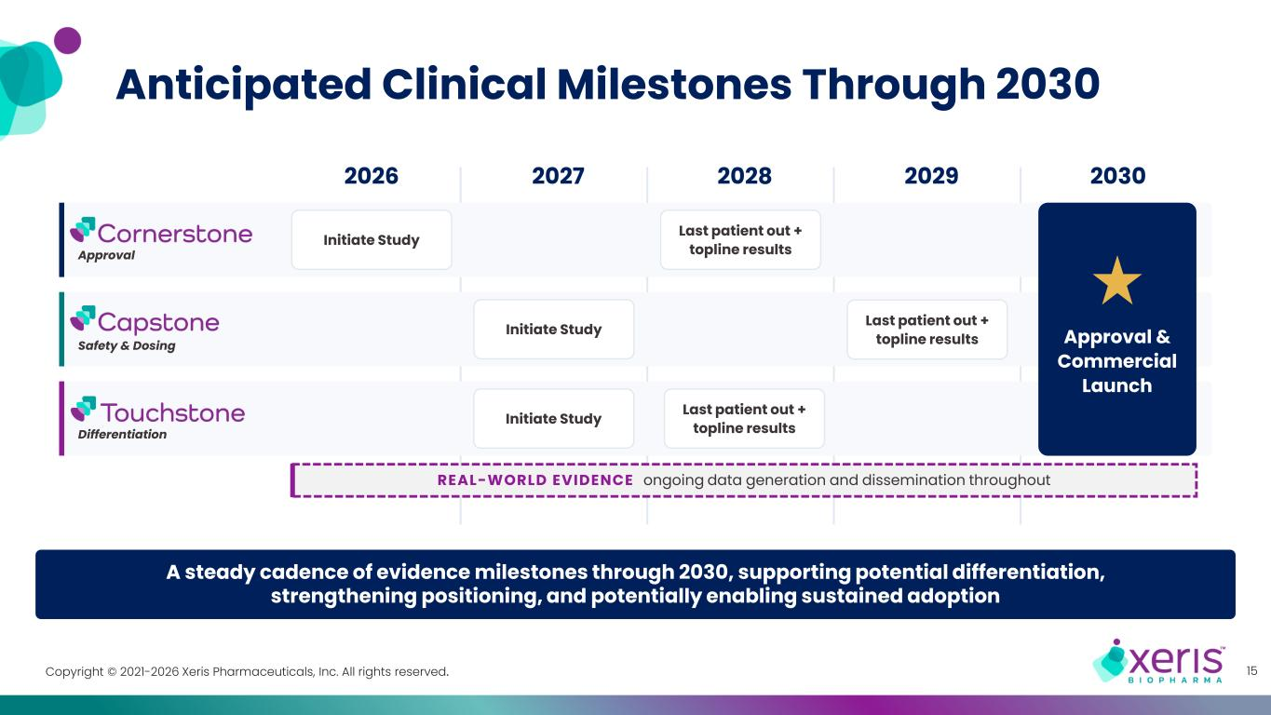
Copyright © 2021-2026 Xeris Pharmaceuticals, Inc. All rights reserved. Anticipated Clinical Milestones Through 2030 15 2026 2027 2028 2029 2030 A steady cadence of evidence milestones through 2030, supporting potential differentiation, strengthening positioning, and potentially enabling sustained adoption REAL-WORLD EVIDENCE ongoing data generation and dissemination throughout Initiate Study Last patient out + topline resultsApproval Initiate Study Last patient out + topline resultsSafety & Dosing Initiate Study Last patient out + topline resultsDifferentiation Approval & Commercial Launch

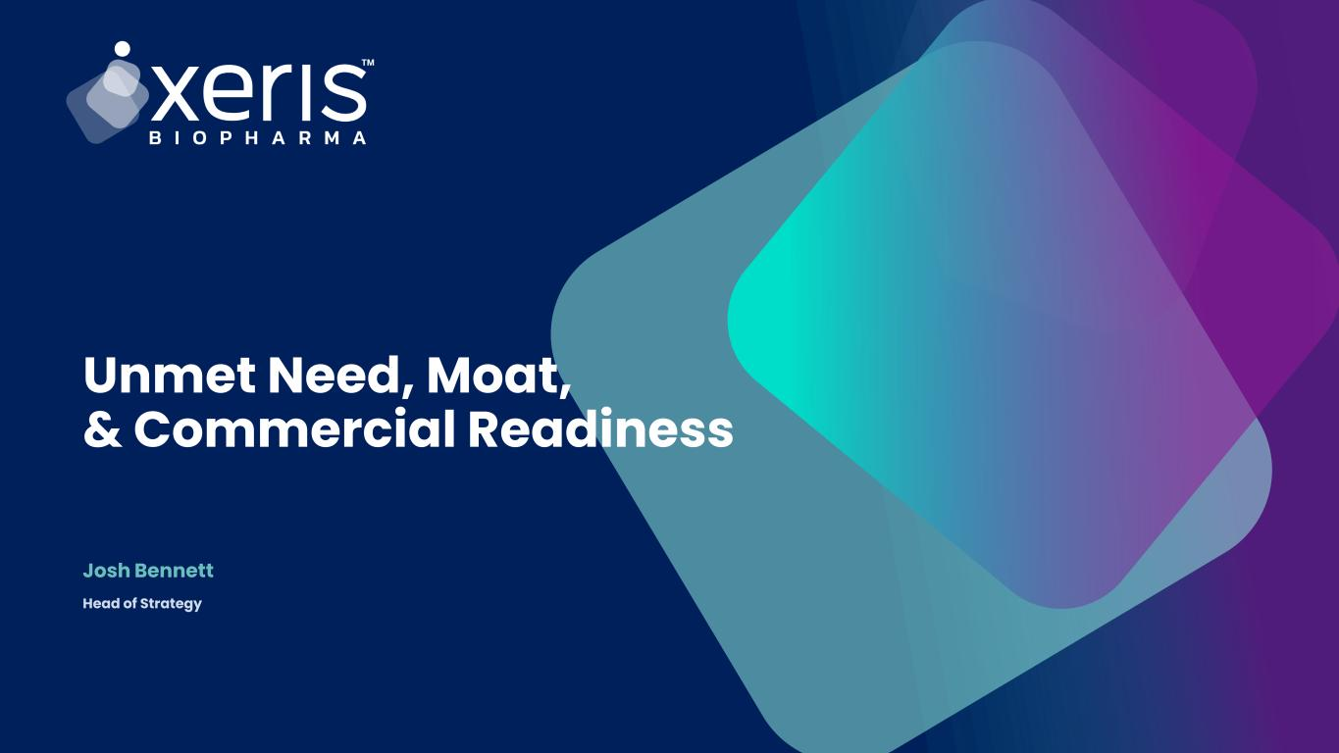
Joshua Bennett Unmet Need, Moat, & Commercial Readiness Josh Bennett Head of Strategy

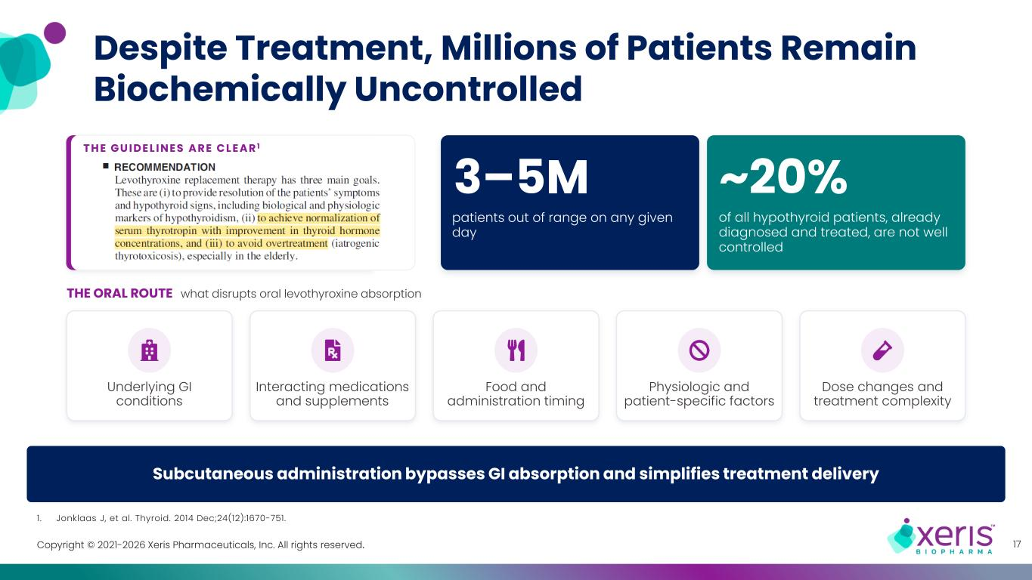
Copyright © 2021-2026 Xeris Pharmaceuticals, Inc. All rights reserved. 1. Jonklaas J, et al. Thyroid. 2014 Dec;24(12):1670-751. Subcutaneous administration bypasses GI absorption and simplifies treatment delivery T H E G U I D E L I N E S A R E C L E A R 1 Despite Treatment, Millions of Patients Remain Biochemically Uncontrolled 17 THE ORAL ROUTE what disrupts oral levothyroxine absorption Underlying GI conditions Interacting medications and supplements Food and administration timing Physiologic and patient-specific factors Dose changes and treatment complexity patients out of range on any given day ~20% of all hypothyroid patients, already diagnosed and treated, are not well controlled 3–5M

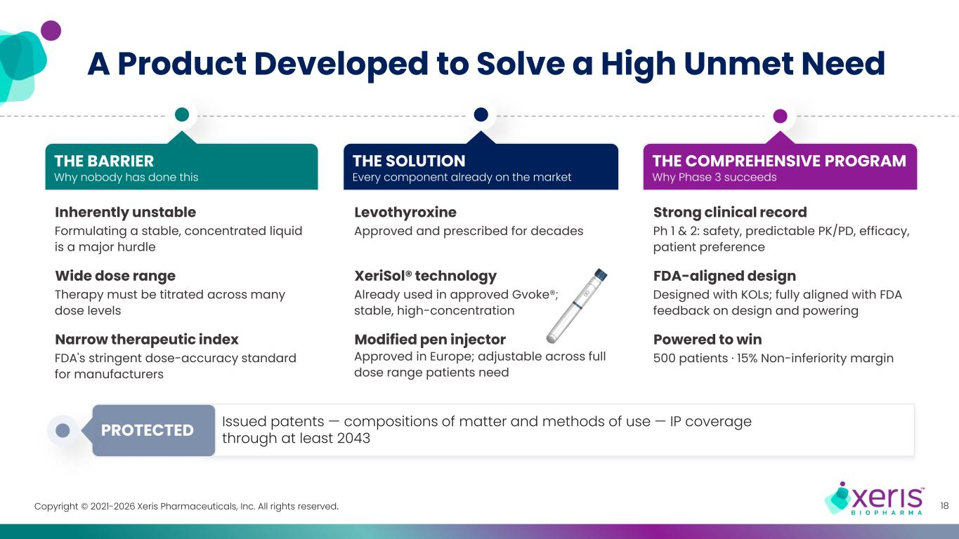
Copyright © 2021-2026 Xeris Pharmaceuticals, Inc. All rights reserved. Issued patents — compositions of matter and methods of use — IP coverage through at least 2043PROTECTED A Product Developed to Solve a High Unmet Need 18 Inherently unstable Formulating a stable, concentrated liquid is a major hurdle Wide dose range Therapy must be titrated across many dose levels Narrow therapeutic index FDA's stringent dose-accuracy standard for manufacturers THE BARRIER Why nobody has done this Strong clinical record Ph 1 & 2: safety, predictable PK/PD, efficacy, patient preference FDA-aligned design Designed with KOLs; fully aligned with FDA feedback on design and powering Powered to win 500 patients · 15% Non-inferiority margin THE COMPREHENSIVE PROGRAM Why Phase 3 succeeds Levothyroxine Approved and prescribed for decades XeriSol® technology Already used in approved Gvoke®; stable, high-concentration Modified pen injector Approved in Europe; adjustable across full dose range patients need THE SOLUTION Every component already on the market

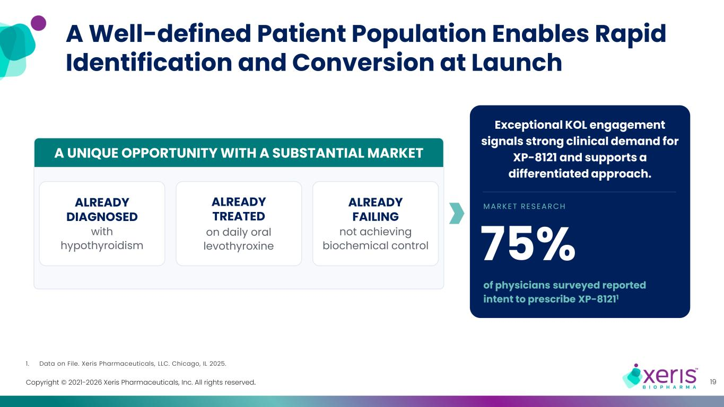
Copyright © 2021-2026 Xeris Pharmaceuticals, Inc. All rights reserved. 19 MARK E T RE S E ARCH of physicians surveyed reported intent to prescribe XP-81211 Exceptional KOL engagement signals strong clinical demand for XP-8121 and supports a differentiated approach. A Well-defined Patient Population Enables Rapid Identification and Conversion at Launch 1. Data on File. Xeris Pharmaceuticals, LLC. Chicago, IL 2025. ALREADY FAILING not achieving biochemical control A UNIQUE OPPORTUNITY WITH A SUBSTANTIAL MARKET ALREADY TREATED on daily oral levothyroxine ALREADY DIAGNOSED with hypothyroidism 75%

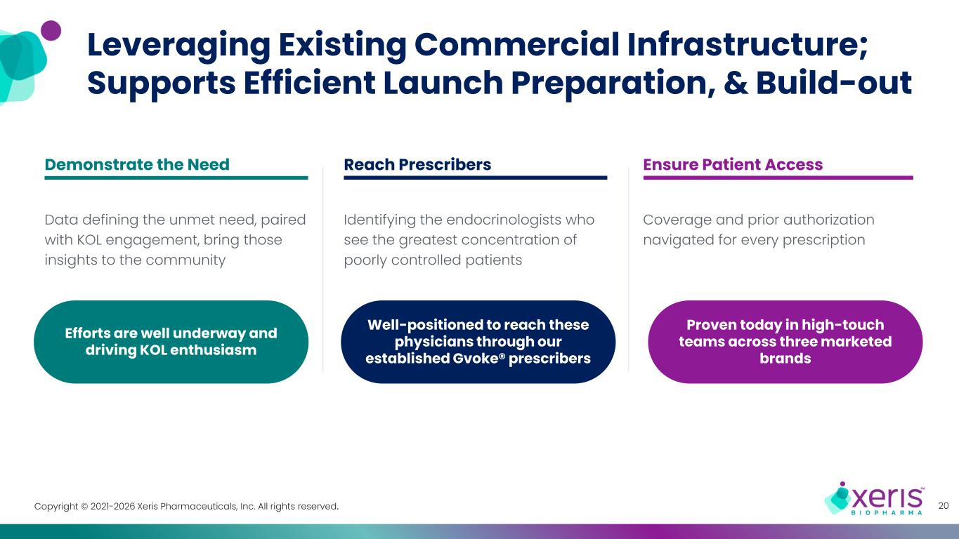
Copyright © 2021-2026 Xeris Pharmaceuticals, Inc. All rights reserved. Leveraging Existing Commercial Infrastructure; Supports Efficient Launch Preparation, & Build-out 20 Demonstrate the Need Data defining the unmet need, paired with KOL engagement, bring those insights to the community Efforts are well underway and driving KOL enthusiasm Reach Prescribers Identifying the endocrinologists who see the greatest concentration of poorly controlled patients Well-positioned to reach these physicians through our established Gvoke® prescribers Ensure Patient Access Coverage and prior authorization navigated for every prescription Proven today in high-touch teams across three marketed brands

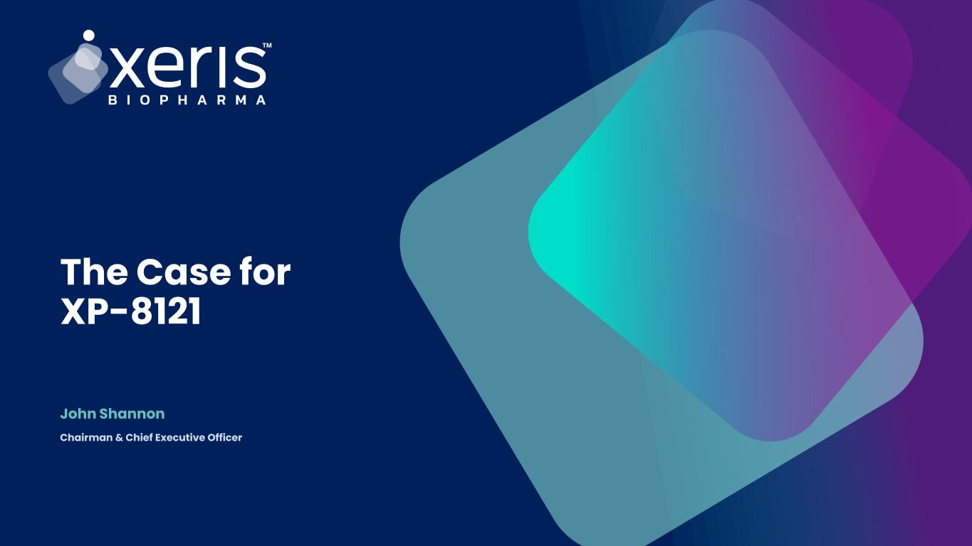
Joshua Bennett The Case for XP-8121 John Shannon Chairman & Chief Executive Officer

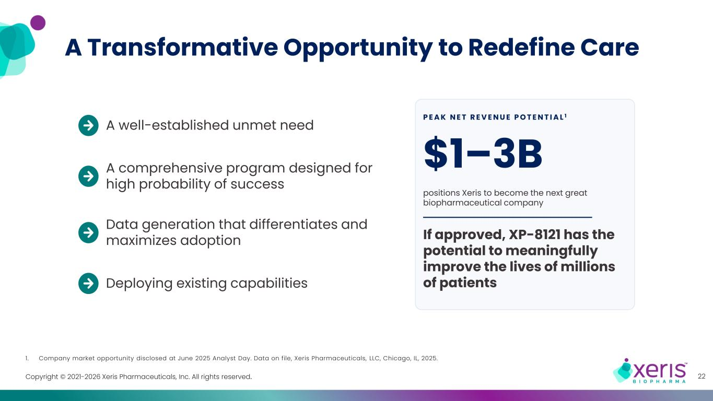
Copyright © 2021-2026 Xeris Pharmaceuticals, Inc. All rights reserved. A Transformative Opportunity to Redefine Care 22 1. Company market opportunity disclosed at June 2025 Analyst Day. Data on file, Xeris Pharmaceuticals, LLC, Chicago, IL, 2025. A well-established unmet need A comprehensive program designed for high probability of success Data generation that differentiates and maximizes adoption Deploying existing capabilities P E A K N E T R E V E N U E P O T E N T I A L 1 $1–3B positions Xeris to become the next great biopharmaceutical company If approved, XP-8121 has the potential to meaningfully improve the lives of millions of patients

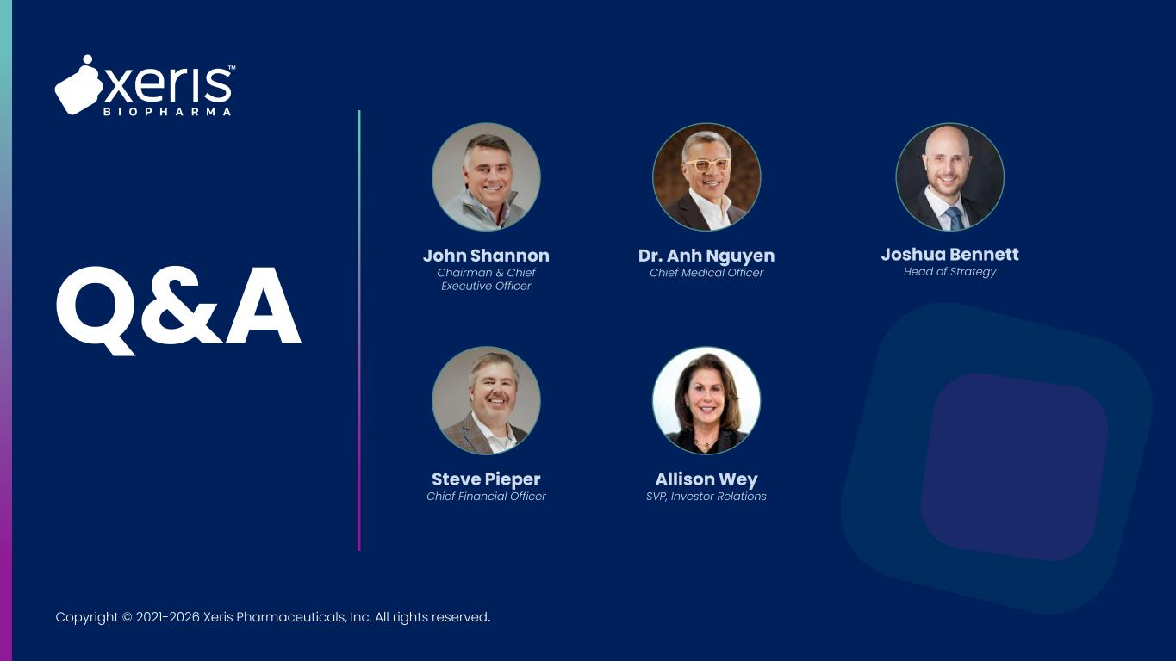
Copyright © 2021-2026 Xeris Pharmaceuticals, Inc. All rights reserved. Q&A John Shannon Chairman & Chief Executive Officer Dr. Anh Nguyen Chief Medical Officer Joshua Bennett Head of Strategy Steve Pieper Chief Financial Officer Allison Wey SVP, Investor Relations


Copyright © 2021-2026 Xeris Pharmaceuticals, Inc. All rights reserved. Thank You Nasdaq: XERS | xerispharma.com

Exhibit 99.2
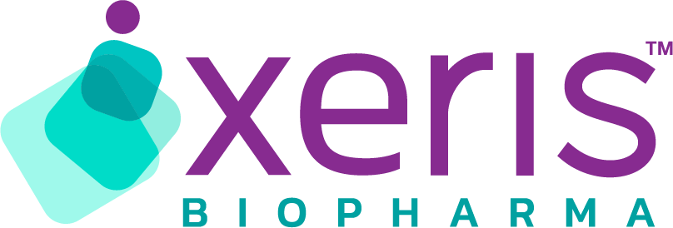
XERIS HOSTS WEBINAR DETAILING ITS COMPREHENSIVE DEVELOPMENT PROGRAM FOR XP-8121, AN INVESTIGATIONAL, ONCE-WEEKLY SUBCUTANEOUS LEVOTHYROXINE FOR HYPOTHYROIDISM

Initiation of Phase 3 registrational study on track by year-end; topline results expected in late 2028; U.S. FDA approval and launch anticipated in 2030

The Company expects XP-8121 peak net revenue potential of $1 to $3 billion

CHICAGO, IL; September 9, 2026 – Xeris Biopharma Holdings, Inc. (Nasdaq: XERS), a fast-growing biopharmaceutical company committed to improving patient lives by developing and commercializing innovative products across a range of therapies, will host an XP-8121 Program Overview today at 10 a.m. ET detailing a comprehensive clinical development strategy, including Cornerstone, its Phase 3 registrational study design, as well as the commercial opportunity for XP-8121, its investigational once-weekly subcutaneous levothyroxine formulation for the treatment of hypothyroidism.

"We are excited to showcase our comprehensive development program for XP-8121 and highlight why we have a high level of confidence in its success,” said John Shannon, Chairman and Chief Executive Officer, Xeris. “With a well-established unmet need, and a differentiated product profile, we believe that XP-8121 could reach $1 to $3 billion in peak net revenue, cementing Xeris as a leading biopharmaceutical company. And most importantly, if approved, XP-8121 has the potential to redefine care and improve the lives of millions of patients."

XP-8121's Comprehensive Evidence Generation Program
Cornerstone — Phase 3 Registrational Study
•Objective: To demonstrate that once-weekly subcutaneous XP-8121 is therapeutically equivalent to daily oral levothyroxine in patients with well-controlled hypothyroidism, as required by the U. S. Food and Drug Administration (FDA) for approval.
•Design: Randomized 1:1 controlled study; participants receive subcutaneous XP-8121 or oral levothyroxine for 54 weeks, with treatment assessments and laboratory evaluations conducted every six weeks throughout the study.
•Enrollment: 500 adults and adolescents with well-controlled hypothyroidism across more than 50 U. S. clinical trial sites, representing both community and academic settings.
•Primary endpoint: Proportion of subjects with thyroid-stimulating hormone (TSH) within the normal range at both weeks 48 and 54.
•Key secondary endpoints: Proportion of time TSH and Free T4 are each within normal range during the final 30 weeks of the study; supportive pharmacokinetic (PK) and PK/pharmacodynamic (PD) endpoints designed to quantify the clinical advantages of once-weekly subcutaneous delivery.
•Statistical design: 15% non-inferiority margin; greater than 90% power; informed by feedback from the FDA on endpoints and statistical powering.

Capstone — Pediatric Study
•Objective: To confirm appropriate dosing and evaluate safety of XP-8121 in pediatric patients, extending the evidence base across all age groups.

Touchstone — Special Population Study
•Objective: To evaluate XP-8121 in patients with inconsistent thyroid control despite maximal oral therapy.

Real-world evidence
•Objective: To quantify the burden and consequences of inadequate thyroid control through ongoing analyses of claims and real-world datasets conducted in collaboration with leading experts in the field.

Clinical Perspective

In addition to Company representatives, key opinion leader and Cornerstone investigator Dr. David Robertson, a leading endocrinologist at Atlanta Diabetes Associates and Piedmont Hospital Atlanta with nearly three decades of experience treating complex thyroid and metabolic conditions, will participate in today's program overview.

“As an endocrinologist and clinical investigator, I see firsthand the challenges that persist for patients who cannot achieve TSH normalization on existing oral therapies,” said Dr. David Robertson. “Despite our best efforts, a meaningful subset of patients faces a frustrating cycle of dose escalations, repeated testing, and persistent symptoms, driven by factors such as unreliable GI absorption, drug interactions, and comorbid conditions. For the first time in decades, XP-8121 offers a fundamentally different approach to levothyroxine delivery. It has the potential to help difficult-to-treat patients achieve biochemical control and reach their treatment goals. The Phase 1 and Phase 2 data provide meaningful foundation around its safety profile and dose-conversion results, and I look forward to serving as an investigator in the Cornerstone study to help in the process towards generating additional data and potentially bringing a new option closer to the patients who need it most.”

How to Register and Access the Event
The XP-8121 Program Overview webinar will be held today, Wednesday, September 9, at 10 a.m. ET.

For registration and access, please click here. A replay of the event, along with the related presentation materials, will also be made available on the "Events and Presentations" section of the Company's Investor Relations website following the live presentation.

About Hypothyroidism
Hypothyroidism affects approximately 20 million Americans, the majority of whom are managed with daily oral levothyroxine. Despite treatment, an estimated 3 to 5 million patients fail to achieve adequate biochemical control, largely due to gastrointestinal absorption variability associated with oral administration. Uncontrolled hypothyroidism is associated with meaningful clinical consequences, including cardiovascular disease and increased mortality.

About XP-8121
XP-8121 is a Phase 3-ready, once-weekly subcutaneous injection in development for the treatment of hypothyroidism. The program is designed to address persistent challenges associated with existing thyroid hormone replacement therapy and has the potential to provide a differentiated treatment option for people living with hypothyroidism and physicians.

About Xeris
Xeris (Nasdaq: XERS) is a fast-growing biopharmaceutical company committed to improving patient lives by developing and commercializing innovative products across a range of therapies. Xeris has three commercially available products: Recorlev®, for the treatment of endogenous Cushing’s syndrome; Gvoke®, a ready-to-use liquid glucagon for the treatment of severe hypoglycemia; and Keveyis®, a proven therapy for primary periodic paralysis. Xeris also has a pipeline of development programs led by XP-8121, a Phase 3-ready, once-weekly subcutaneous injection for hypothyroidism, as well as multiple early-stage programs leveraging Xeris’ technology platforms, XeriSol® and XeriJect®, for its partners.
Xeris Biopharma Holdings is headquartered in Chicago, IL.
Forward-Looking Statements
Any statements in this press release other than statements of historical fact are forward-looking statements. Forward-looking statements include, but are not limited to, statements about future expectations, plans, opportunities, and prospects for the Company, including among other things, statement regarding the Company’s comprehensive clinical development program for XP-8121, the design, objectives, endpoints, enrollment, timing, conduct and expected results of the Cornerstone, Capstone, and Touchstone studies, the ability of XP-8121 to demonstrate therapeutic equivalence of daily oral levothyroxine, achieve applicable clinical endpoints and support regulatory approval, the expected initiation of Cornerstone by year-end 2026, the expected initiation of Touchstone in 2027 and completion of Touchstone in time for inclusion in the Company’s New Drug Application submission, and the expected timing of topline results in late 2028, the timing and likelihood of regulatory approval and commercialization of XP-8121, including potential FDA approval and commercial launch in 2030, the market and therapeutic and commercial potential of its products and product candidates, including its expectations regarding

the potential of XP-8121 to provide biochemical control, improve patient outcomes and redefine care, and its estimated peak net revenue or sales potential of $1 billion to $3 billion, the timing, duration, and expected results of clinical trials, the timing and expected regulatory approval of its product candidates, the potential utility of its formulation platforms, the advancement of its pipeline, and other statements containing the words "achieve," "anticipate," “believe,” “continue,” “expect,” “estimate,” “potential,” “should,” “will,” “would,” and similar expressions, constitute forward-looking statements within the meaning of The Private Securities Litigation Reform Act of 1995. These forward-looking statements are based on numerous assumptions and assessments made in light of Xeris’ experience and perception of historical trends, current conditions, business strategies, operating environment, future developments, geopolitical factors, and other factors it believes appropriate. By their nature, forward-looking statements involve known and unknown risks and uncertainties because they relate to events and depend on circumstances that will occur in the future. The various factors that could cause Xeris’ actual results (including revenue and sales in the near- and long-term), performance or achievements, industry results, market opportunity and developments to differ materially from those expressed in or implied by such forward-looking statements , include, but are not limited to, its financial position and need for financing, including to fund its product development programs or commercialization efforts, whether its products will achieve and maintain market acceptance in a competitive business environment, its reliance on third-party suppliers, including single-source suppliers, its reliance on third parties to conduct clinical trials, the risk that clinical trials may not be initiated, enrolled, or completed on anticipated timelines, or at all, the risk that results of earlier clinical trials may not be predictive of the results of later-stage clinical trials or may not support regulatory approval, the possibility that the FDA may disagree with the design or conduct of the Company’s clinical trials or require additional clinical trials or data, the ability of its product candidates to compete successfully with existing and new drugs, its and collaborators’ ability to protect its intellectual property and proprietary technology, the accuracy and completeness of its assumptions and its ability to accurately estimate future financial results and market opportunities, and general macroeconomic and geopolitical conditions, including the possibility of an economic downturn, political unrest, trade disputes, changes in U.S. governmental priorities and resources, announced or implemented tariffs or export controls and market volatility. No assurance can be given that such expectations will be realized and persons reading this communication are, therefore, cautioned not to place undue reliance on these forward-looking statements. Additional risks and information about potential impacts of financial, operational, economic, competitive, regulatory, governmental, technological, and other factors that may affect Xeris can be found in Xeris’ filings, including its most recently filed Annual Report on Form 10-K and subsequent filings with the U.S. Securities and Exchange Commission, the contents of which are not incorporated by reference into, nor do they form part of, this communication. The risks described herein and in Xeris’ U.S. Securities and Exchange Commission filings are not the only risks the Company faces. Additional risks and uncertainties not currently known to it or that it currently deems immaterial may also impact its business operations or financial results. Forward-looking statements in this communication are based on information available to management, as of the date of this communication and, while the Company believes its assumptions are reasonable, actual results may differ materially. Subject to any obligations under applicable law, the Company does not undertake any obligation to update any forward-looking statement whether as a result of new information, future developments or otherwise, or to conform any forward-looking statement to actual results, future events, or to changes in expectations.

Investor Contact
Allison Wey
Senior Vice President, Investor Relations
ir@xerispharma.com

